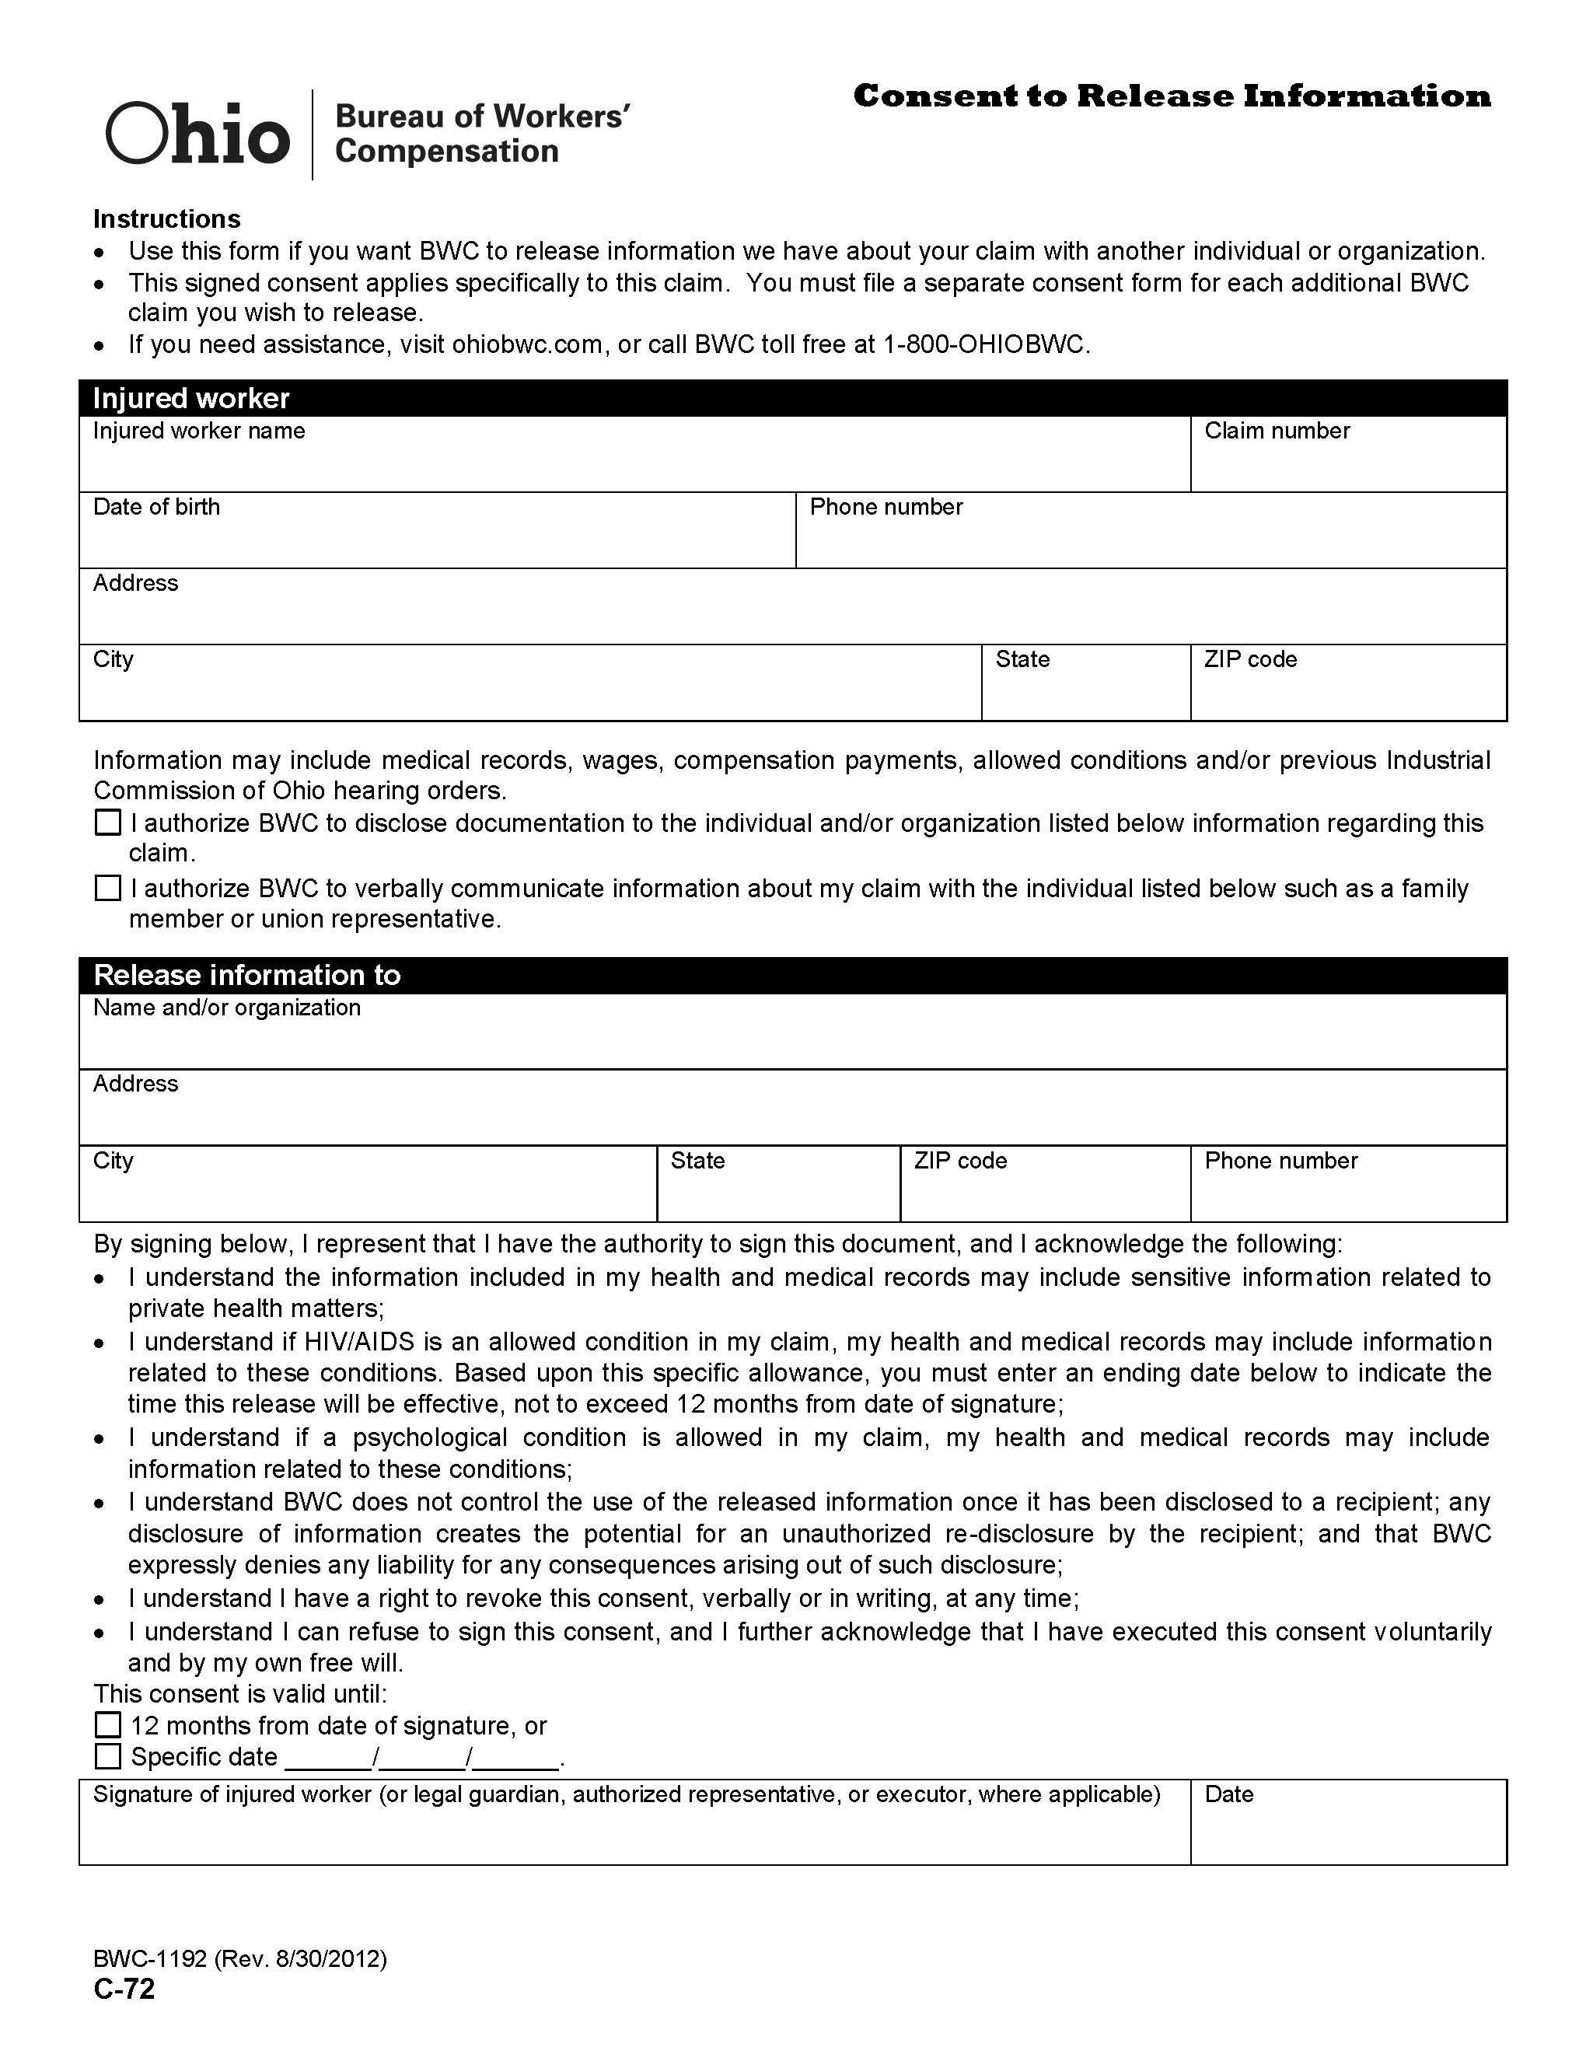
Batman
01/01/1979

Secret Location Under Office Building
Gotham
NJ

x
Axiom Requisition Copy Service
2869 Jolly Road
Okemos
MI
48864
(877) 886-5090

